We are given the head node root of a binary tree, where additionally every node's value is either a 0 or a 1.

Return the same tree where every subtree (of the given tree) not containing a 1 has been removed.

(Recall that the subtree of a node X is X, plus every node that is a descendant of X.)

**Example 1:**

**Input:** [1,null,0,0,1]

**Output:** [1,null,0,null,1]

**Explanation:**

Only the red nodes satisfy the property "every subtree not containing a 1".

The diagram on the right represents the answer.

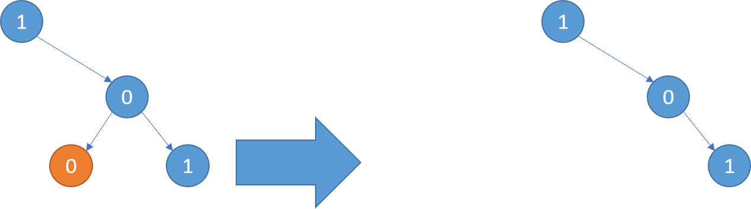

**Example 2:**

**Input:** [1,0,1,0,0,0,1]

**Output:** [1,null,1,null,1]

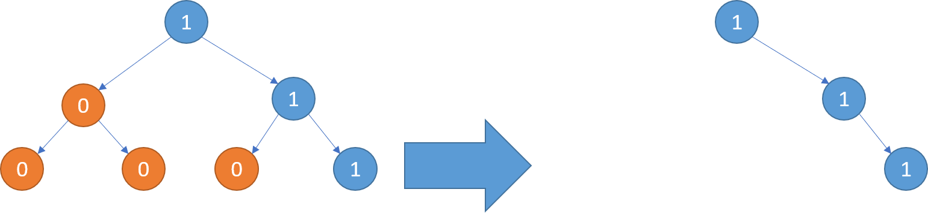

**Example 3:**

**Input:** [1,1,0,1,1,0,1,0]

**Output:** [1,1,0,1,1,null,1]

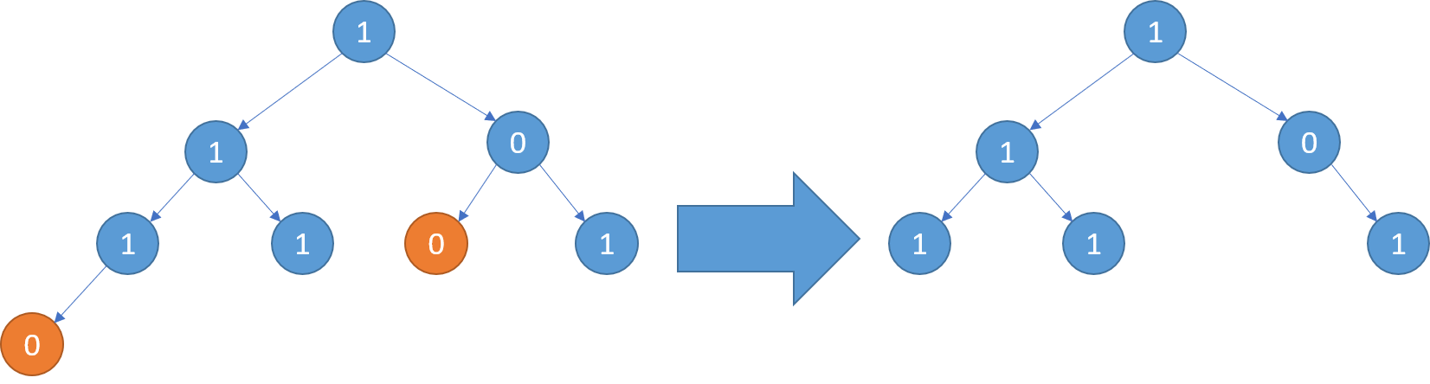

**Note:**

* The binary tree will have at most 100 nodes.
* The value of each node will only be 0 or 1.